Nutshells are a good addition

[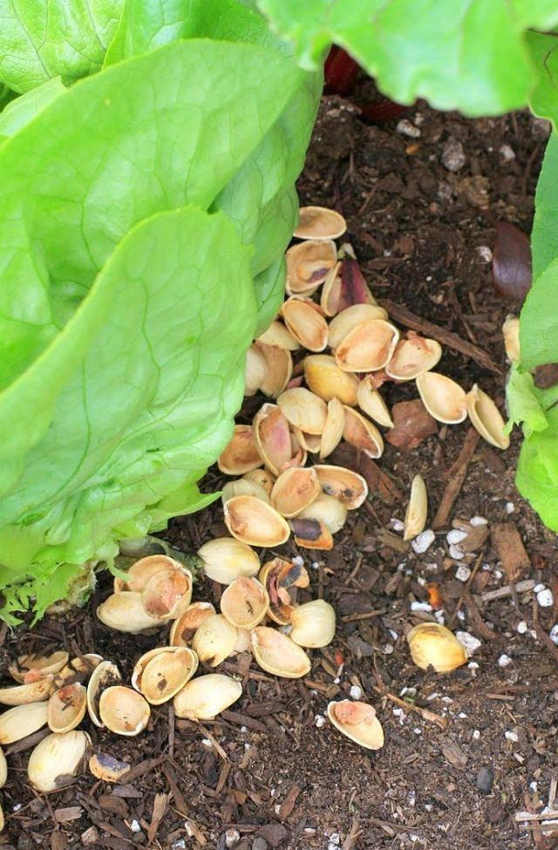](https://balconygardenweb-lhnfx0beomqvnhspx.netdna-ssl.com/wp-content/uploads/2016/06/nut-shells-in-garden.jpg)

The Nut shells are a good addition to your compost heap because they don’t break down as quickly as other items. Nut shells also work well as a mulch, the reason is same– they don’t break down easliy. In compost, they can help vary the thickness of it, this later helps in soil aeration. A warning: don’t use black walnut nut hulls beacuse they have a large concentrations of juglone which is toxic to many plants.